**EXPERIMENT 2**

**AIM: Working with Docker (Basic Commands)**

**Steps to Complete:**

1. Search a Redis image on DockerHub  
   A screenshot of a computer

   Description automatically generated
2. Run Docker Container of Redis Image in background  
   A computer screen with white text

   Description automatically generated
3. Run Docker PS and Docker PS –a  
   A black screen with white text

   Description automatically generated
4. Run Docker Container and take its console  
   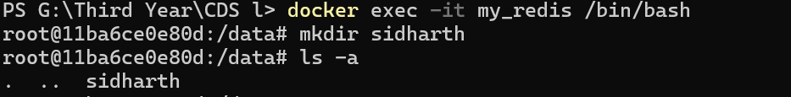
5. Create a Docker Volume and connect it  
   